NUMPY WORKSHEET
Review the following exploration of the given dataset (SALES.CSV) 1 How do you install NumPy? Review the following exploration of the given dataset (SALES.CSV)

1 How do you install NumPy?
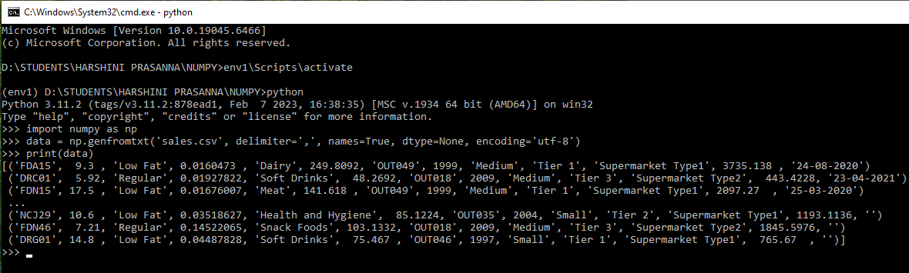
2 Load the dataset and preview the first few rows to understand its structure?
3 Determine the number of rows and columns in the dataset.
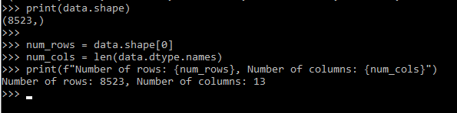
4 Calculate the minimum, maximum, mean, and standard deviation for numerical columns.
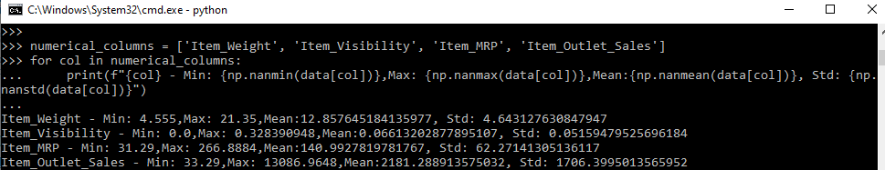
5 Count the no. of unique values in a categorical column like Item_Type.
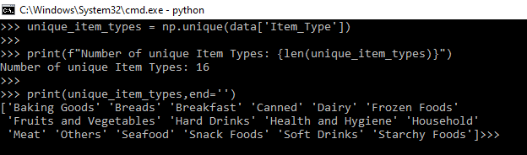
6 Filter and display all rows where Item_Fat_Content is Low Fat.
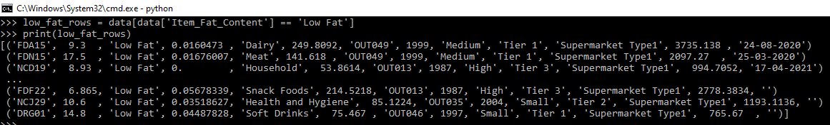
7 Extract only the Item_MRP and Item_Outlet_Sales columns.
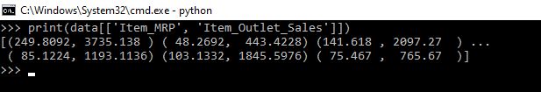
8 Find the difference between the maximum and minimum item weights.
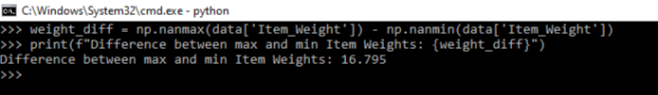
9 Count how many items are sold in each Outlet_Type.
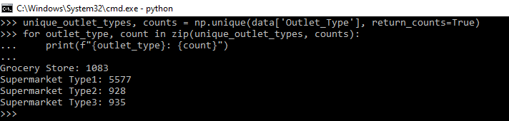
10 Identify the items with the highest and lowest Item_Outlet_Sales.
11 Check if any column has missing values.
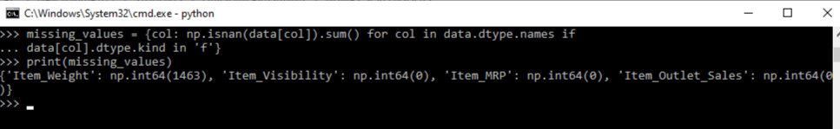

12 Calculate the total sales amount in the dataset.
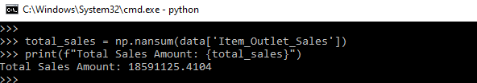
13 Count the no. of rows with missing values in the Item_Weight column.
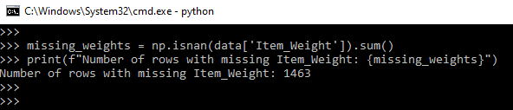
14 Find the items with the highest Item_MRP value.
15 Calculate the average sales amount for each outlet.
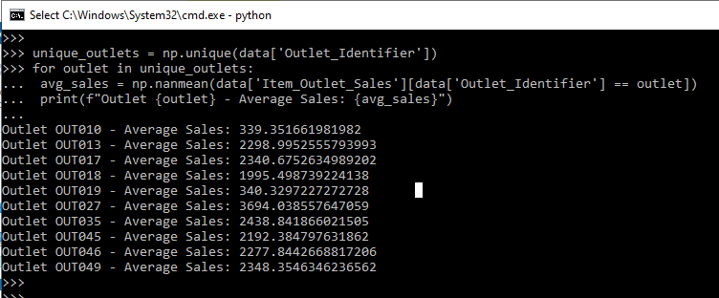
16 Identify the top 5 outlets with the highest total sales.
unique_outlets = np.unique(data['Outlet_Identifier']) total_sales_by_outlet = {outlet: np.nansum(data['Item_Outlet_Sales'][data['Outlet_Identifier'] == outlet]) for outlet in unique_outlets} sorted_outlets = sorted(total_sales_by_outlet.items(), key=lambda x: x[1], reverse=True)[:5] print(f"Top 5 outlets by total sales: {sorted_outlets}")

17 Analyze how sales have grown over the years.
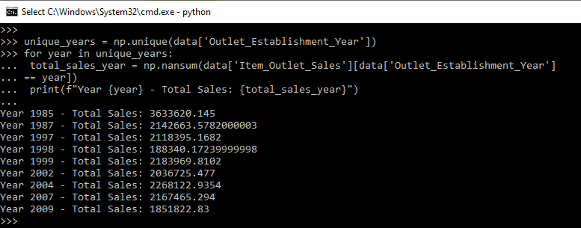
18 Identify outliers in Item_MRP.
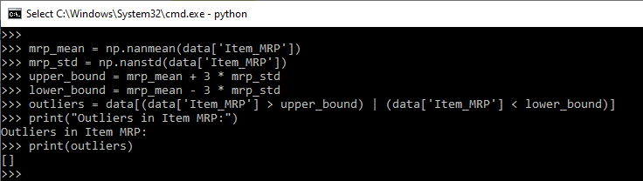
19 Calculate total sales based on Outlet_Location_Type.
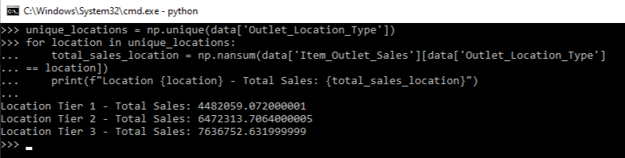
20 Calculate the average Item_Visibility for each Item_Type.
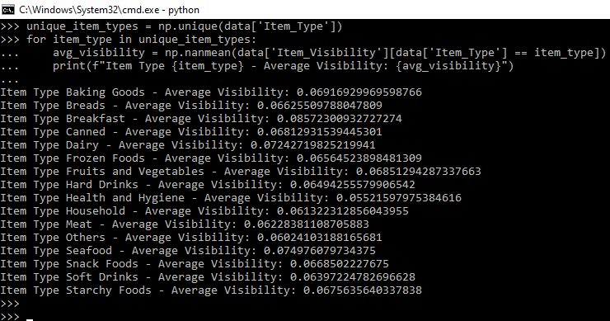
21 Calculate the percentage contribution of each item to the total sales.
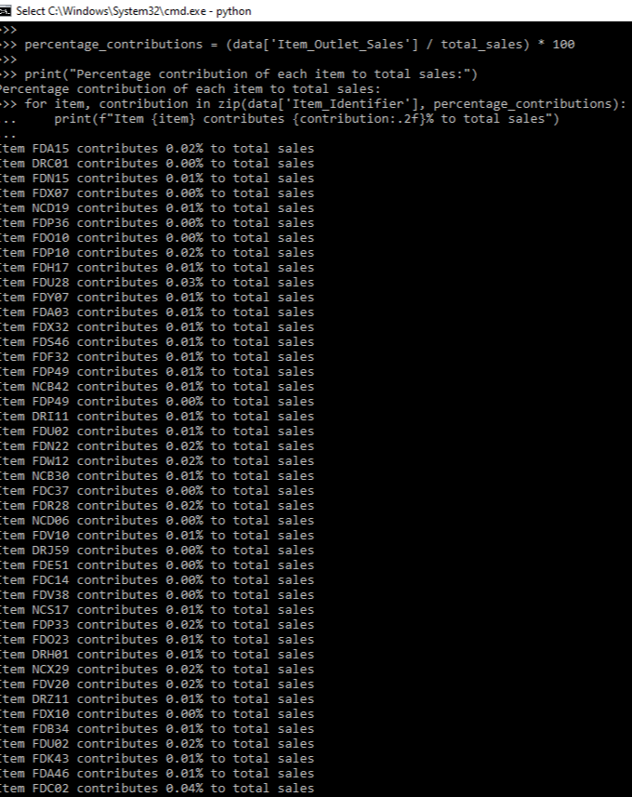

22 Analyze the total sales by different outlet types.
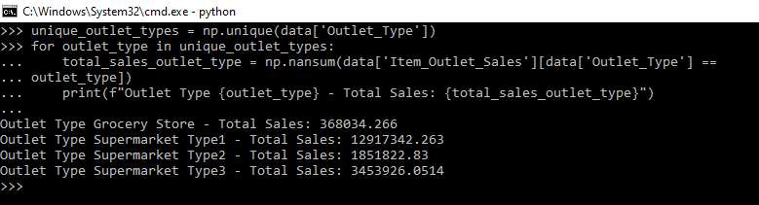
23 Identify the item type with the highest total sales.
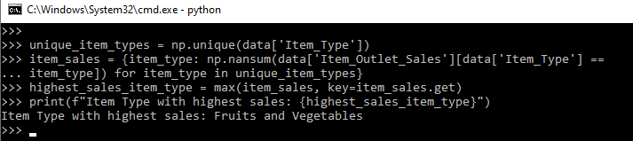
24 Analyze sales trends over months to identify any seasonal patterns.
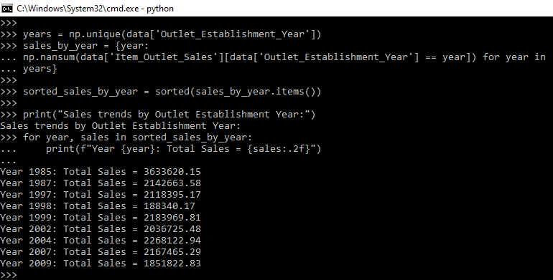
25 Identify items with the highest profit margin if cost data is available.
Cost data not available so unable to find the highest profit margin
26 Calculate the average Item_Outlet_Sales for each Outlet_Size. 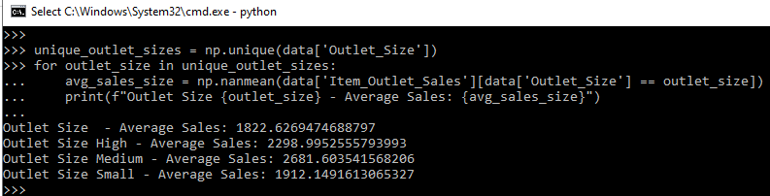
27 Explore how Item_Visibility affects Item_Outlet_Sales.
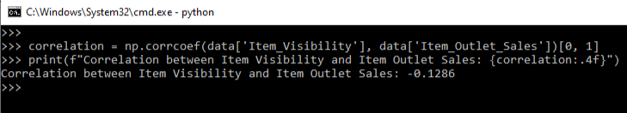
28 Sum up the total sales for each Item_Type.
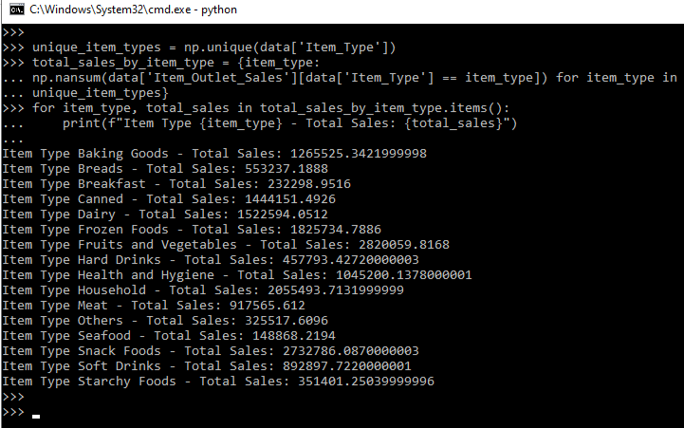
29 Calculate the median Item_MRP for each Outlet_Type.
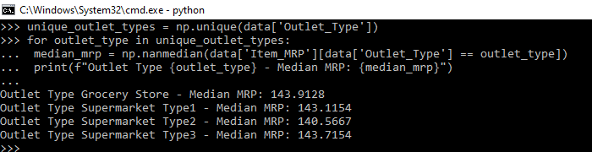30 Find the most frequently occurring Item_Fat_Content category. 